Week 4 Food Plan and Shopping List

Variety is truly the spice of life, and we don’t want you ever to be bored on the Health Plus food plan. With a little bit of effort and creativity, you can enjoy a wide range of tasty, satisfying low-fat foods every day. In this section you will find dozens of great food ideas. Glance through the lists below whenever you need quick ideas about what to have for breakfast, lunch, dinner, or a snack. Check out the sample menus that follow—we’ve included four weeks’ worth of super-easy menus, each with a grocery list, and recipes. These menus are planned for convenience, with very little cooking to do. For you chefs out there, we’ve included an additional sampling of great recipes to try. All are healthy, low-fat, and delicious. You’ll see new recipes in on our Web site area each week. Feel free to bring us your favorites to post when you come for your appointment.

Be sure to pick up a card with the login name and password for the recipe section of Healthplustoday.com. Search for recipes with the ingredients you have on hand, or by meal type.

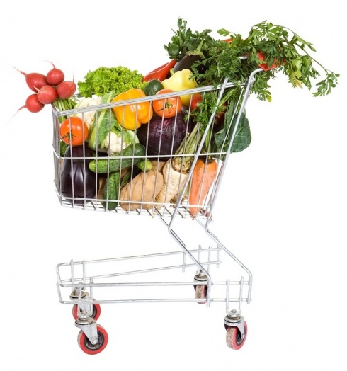

Breakfast Choices

- Cold Cereal: High Fiber (All bran, Cracklin’ Oat Bran, Low-Fat Granola, Grape Nut Flakes, Shredded Wheat, Raisin Bran, Wheaties) with 1/2 Cup Skim Milk 160/0

- Hot Cereal: Oatmeal or cream of wheat or grits made with 1/2 Cup Skim Milk 200/2.5

- Toast Breakfast: Use a low-calorie, high fiber bread like Orowheat light bread, a Sandwich Thin, or English Muffin and 2 Tablespoons honey, jelly or jam 220/2

- Spinach Scramble: 3/4 Cup Eggbeaters or Egg whites with cut fresh spinach. Serve in a 6 to 8 in fat-free flour or corn tortilla 180/2

- French Toast: 2 pieces bread dipped in 6 Tablespoons Eggbeaters or egg whites and ¼ Cup non-fat milk 295/0

- Veggie Omelet: Use cooking spray in a small pan and add 4 Egg Whites or 1 Cup Eggbeaters, diced peppers, mushrooms, onions 140/0. Serve with a toasted English muffin 100/0

- Yogurt with Fruit: 6 oz. non-fat yogurt with fresh fruit: ½ cup Strawberries or blueberries, ½ banana and 2 ounces diced pineapple 150/0

- Chicken Sausage Breakfast: Cook 2 Iserno’s Low-fat Chicken Sausages and dice into 3/4 Cup Eggbeaters or 3 egg whites with cut fresh spinach 220/2.5. Use cooking spray in a small pan and cook for 3 minutes on medium high heat. 220/2.5
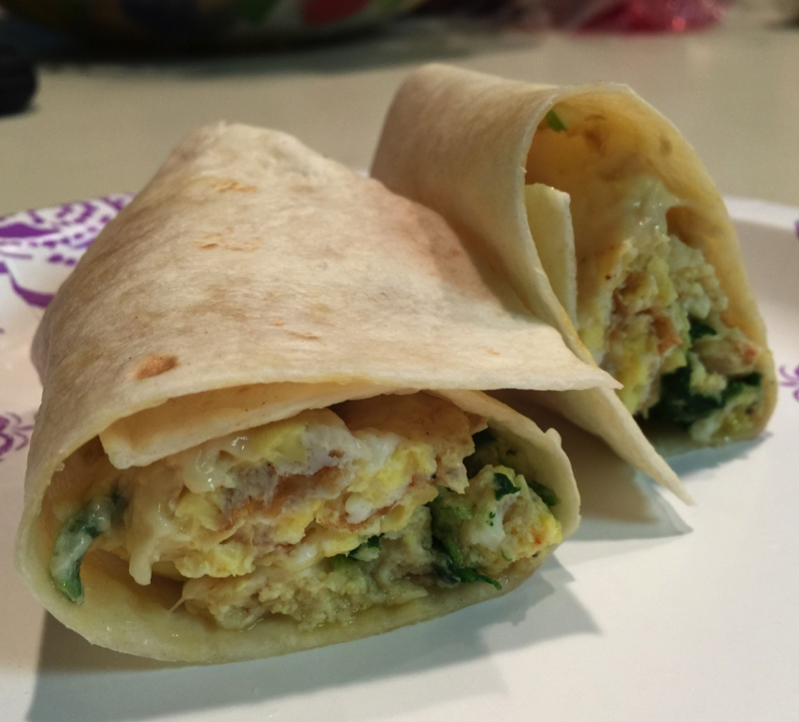

Lunch Choices

- Hummus Sandwich: Whole wheat light bread or a Sandwich Thin, lettuce, tomato, and 3 Tablespoons low-fat hummus 160/6

- Turkey Roll-up: Flour tortilla, non-fat cream cheese, 3 oz. roasted turkey without skin, shredded lettuce and tomatoes 345/5

- Tuna Sandwich: Light bread or a Sandwich Thin, 3 ounces canned albacore tuna packed in water, non-fat mayonnaise, lettuce and tomatoes 260/3.5
- Pita Sandwich: 3 ounces garbanzo beans, veggies, non-fat Italian dressing 380/4.5

- Turkey burger (Trader-Joe’s or 98% Jennie-O Lean) 4 oz. patty, grilled, on whole wheat bun, and barbeque sauce 240/3.5

- Veggie Pasta Salad: 1/2 Cup corkscrew pasta (90/0.5), celery, 3 Tablespoons boiled carrots (10/0), 3 oz. black beans (110/0.5), capers, non-fat Italian dressing 220/1

- Subway Sandwich (6 grams fat or less, no cheese or mayo) 280/3.5

- Chicken Sandwich: skinless breast meat (grilled or roasted) on a Sandwich Thin or other low-fat bread plus barbeque sauce or ketchup or other fat-free condiments 285/6

- Broccoli Potato: Top a 6 oz. baked potato with 4 oz. steamed broccoli & 3 Tablespoons non-fat sour cream) 240/1

- Salad: 8 oz lettuce or spinach (55/1), 2” tomato sliced (20/0), 3 oz Pollock or imitation crab (90/1), 3 Tablespoons mango salsa (30/0) non-fat dressing & small dinner roll (75/2) 270/4

- Yogurt & Fruit: One 4 or 5 ounce container of fat-free Yogurt with bananas, strawberries or other cut-up fresh fruit 160/0

Dinner Choices

- 1 Cup Whole wheat pasta with ½ Cup tomato sauce 175/1

- French Roll pizza – use half; top with ½ Cup tomato sauce, 1 piece string cheese, 1 Cup chopped bell peppers, 1 cup mushrooms, 1 whole tomato sliced 195/3.5

- Home made burrito (1 8” flour tortilla, ½ Cup black beans, ½ Cup brown rice, 2 Tablespoons fat-fee sour cream 410/5.5

- Grilled Tilapia (or other white fish) 4 ounces - marinated in non-fat sauce, with a 2” boiled or baked red potato 235/3

- Turkey burger (Trader-Joe’s or 98% Jennie-O Lean) 4 oz. patty, grilled, on whole wheat bun, and barbeque sauce 240/3.5

- Sweet Potatoes – 1 Cup mashed or 1 9” baked with
2 Tablespoons fat-free sour cream 260/0.5

- Potato wedges (spray cookie sheet lightly with Pam and add cut up one 12 ounce red potato, bake at 400° until slightly crispy, season with salt, and serve with ketchup or barbeque sauce) 270/0

- Chicken Taco: 1 corn tortilla, 1 Tablespoon mango salsa, 3 ounces roasted chicken breast without skin, chopped lettuce, tomato and red onion 270/4

- Rice and Veggies: ¾ Cooked brown rice and sliced veggies simmered in Chicken broth: 1 small onion, 1 bell pepper, 1 Cup mushrooms, 2 stalks celery 330/2

- Broccoli and Potatoes: Take a 6-ounce potato and steam it. When it is almost done, add 6 ounces of broccoli. Clean 2 cloves of garlic, and blend in a food processor with 1 Tablespoon olive oil and ¼ Cup (prepared) chicken broth. Pour Sauce over veggies when served. 235/5

Snack Choices

Remember when your mother told you that if you didn’t stop snacking you would spoil your dinner? Well, at Health Plus we encourage snacking! Snacking frequently keeps you from feeling hungry and overeating. However, for weight loss, it is best to keep portion sizes small. Pre-portioned packages of foods like yogurt and crackers may be helpful so if you purchase a box of crackers, portion out handfuls into sandwich bags.
- Snack-Type Food: Matzo with jam, SpecialK Rice crackers with Fat-free sour cream dip, Rice cakes, Pretzels, air-popped or lower fat microwave popcorn - average ~130/1.5

- Yogurt with Fruit: non-fat light fruit or non-fat plain with fresh fruit 140/0

- Fruit Sundae: ½ Cup Apple Sauce with 1 Cup of mixed fresh diced fruit (strawberries, apple, pineapple, blueberries, grapes) and ½ a sliced banana; top with 1 teaspoon Jam 200/0

- Corn tortilla and salsa heated in microwave 100/2

- English muffin pizza (top with spaghetti or pizza sauce, diced veggies such as mushrooms, onions, peppers) 150/0

- Fresh fruit (apples, oranges, clementines, banana, grapes, peach, pear, pineapple slices, seasonal berries, etc) 60-130/0

- Fruit Cup: Packed in water or own juices (applesauce, peaches, pears, mandarin oranges, pineapple etc) 70/0

- Fresh vegetables (sweet peppers, baby carrots, celery sticks, sliced jicama, etc) 40 - 90/0

- Skinny Cow Low-fat frozen dessert average ~140/3

- Rice Chex - 1 cup dry makes a great snack with crunch 110/0

- Go Snack: one That’s It Fruit Bar 100/0, or one Low-Fat Granola bar 140/2.5 or a Snack Box of Raisins 100/0

Beverage Choices

Yes it’s true; water is still the best choice for meeting your fluid needs. However, beverages containing sugar substitutes like Splenda, NutraSweet, & Equal can be safely included in your daily meal plan unless you find that they make you hungry. If you do include beverages with artificial sweeteners, try to limit them to 3 servings a day. If you are having trouble sleeping, and especially if you are taking weight loss medications, try cutting down on the amount of caffeine you drink. To avoid caffeine choose caffeine-free or decaffeinated coffee, teas, and sodas.

- Water (tap, bottled)

- Diet V-8 Splash 50/0 for 8 oz. glass

- Iced Tea - sweeten by the glass with Truvia or Stevia, organic cane sugar or honey

- Vegetable Juice eg. Carrot Juice 40/0 for 8 oz. glass

- Tea with honey, Truvia or organic cane sugar

- Coffee with non-fat milk – for sweeteners, use organic cane sugar instead of refined white sugar, and the least amount possible

- Light cranberry juice 50/0 for 8 oz. glass

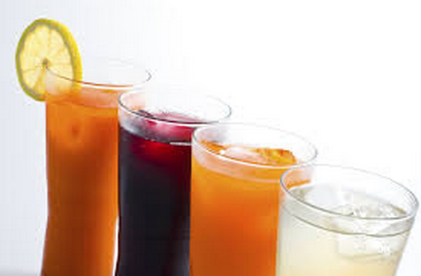

Weekly Menu #4
 | Day 1 |  | Day 2 |  | Day 3 |  | Day 4 |  | Day 5 |  | Day 6 |  | Day 7
Breakfast | Cereal with skim milk 160/0 *see meal lists |  | Spinach Scramble 180/2  *see meal lists |  | Chicken Sausage Breakfast 220/2.5  *see meal lists |  | Hot Cereal Breakfast 200/2.5 *see meal lists |  | Veggie Omelet Breakfast 240/0 *see meal lists |  | Yogurt (6 oz) with fruit 150/0  *see meal lists |  | Chicken Sausage Breakfast 220/2.5  *see meal lists
Snack | 1 Banana 100/0 |  | Applesauce  ½ cup 55/0 |  | 2 Kiwis 95/1 |  | 1 Pear 90/0 |  | Grapes  1 cup 100/0 |  | 1 Peach 70/0 |  | Honeydew Melon 1 cup 60/0
Snack | Yogurt (6 oz) with fruit 150/0  *see meal lists |  | That’s It Fruit Bar 100/0 |  | 1 Corn Tortilla &  salsa 55/0.5  *see snack list |  | 1 Peach 70/0 |  | Fruit Sundae 200/0  *see snack list |  | 2 Plums 75/1 |  | Bell Pepper  1 sliced 45/0
Lunch | Turkey Roll-up 245/3.5  *see meal lists |  | 2 French Roll Pizzas 390/7  *see meal lists |  | Veggie Sandwich 115/0.5  *see recipe |  | Warm Balsamic Bean Salad 185/0  *see recipe |  | Picante Black Bean Soup 255/1  *see recipe |  | Weekender Sandwich 245/3  *see recipe |  | Pineapple Chicken Salad 200/3  *see recipe
Snack | Fruit Sundae 200/0  *see snack list |  | Grapes  1 cup 100/0 |  | 1 Apple 100/0.5 |  | Pretzel Crisps  (1 serving) 110/2 |  | 1 Orange 60/0 |  | Grapes  1 cup 100/0 |  | 1 Banana 100/0
Snack | 10 Raw Almonds 70/6 + Raisins-one snack box 100/0 |  | 1 Banana 100/0 |  | Corn Tortilla with salsa 100/2  *see snack list |  | 10 Raw Almonds 70/6 + Raisins-one snack box 100/0 |  | 10 Raw Almonds 70/6 + Raisins-one snack box 100/0 |  | 10 Raw Almonds 70/6 + Raisins-one snack box 100/0 |  | 10 Raw Almonds 70/6 + Raisins-one snack box 100/0
Snack | 1 Peach 70/0 |  | 8oz NF light yogurt 100/0 |  | That’s It Fruit Bar 100/0 |  | 1 Banana 100/0 |  | 1 Peach 70/0 |  | Corn Tortilla with salsa 100/2  *see snack list |  | That’s It Fruit Bar 100/0
Dinner | Home-made Burrito 410/5.5  Salad 195/2  *see meal lists |  | Rice and Veggies 330/2  Salad 195/2  *see meal lists |  | Citrus Asparagus with orange sauce 60/1  Pasta Cheese Bake 250/2.5  *see recipes |  | Chili Potato 365/1  1 cup spinach 15/0  2 Tbs NF salad dressing 35/0 |  | Chicken Breast 4 oz baked-390/1.5 + Steamed Broccoli 1 cup 50/0 |  | Lasagna Curls 320/3  *see recipes  Acorn Squash  1 baked 85/0 |  | Chicken Dijon  220/3  *see recipes + Steamed Broccoli 1 cup 50/0
Snack | Pretzel Crisps  (1 serving) 110/2 |  | 1 Apple 100/0.5 |  | 1 oz Pretzel Crisps 110/2 |  | Fruit Sundae 200/0  *see snack list |  | Raisins-one snack box 100/0 |  | Fruit Sundae 200/0  *see snack list |  | Fruit Sundae 200/0  *see snack list
Total: | 1810/19 |  | 1630/13.5 |  | 1205/12.5 |  | 1540/11.5 |  | 1635/8.5 |  | 1515/15 |  | 1505/14.5

Grocery List – Weekly Menu #4

Canned/Packaged Food
Raisin Bran
Rice Chex
Oatmeal
Granola, low-fat (Trader Joes)
Garbanzo beans, canned
Black beans, canned
Barbeque sauce
Spaghetti sauce
1 pkg Lasagna Noodles

Bread/Grain/Rice/Pasta
1 pkg Pita Bread
1 loaf Whole wheat low-fat bread
Tortillas, corn & Canteca non-fat Flour (Winco)
1 Box Matzoh
1 pkg French Rolls
Brown Rice

Fruit
3 Bananas
2 Apples
Apple Sauce
2 Oranges / tangerines
1 pint of Orange Juice
1 Pear
4 Peaches
2 Plums
Diet V-8 Splash
1 Honeydew Melon
Seedless Red and/or Green Grapes
Pineapple or fresh cut pineapple (Winco)
Strawberries
Blueberries
2 Kiwis

Vegetables
Asparagus
Lettuce
Spinach
3 Tomatoes
4 Cucumbers
3 Bell peppers
2 Bunches green onions
Celery
Mushrooms
3 Potatoes
Broccoli
1 Acorn Squash
2 packages shredded carrots
Onions
Fresh Basil, Oregano & Parsley

Dairy/ Eggs
Non-fat milk or soy milk
Egg Substitute (Egg Beaters)
Jumbo Eggs
6 Non-fat Yogurts with fruit 6 oz containers
1 10 oz. Plain non-fat Yogurt
1 8oz fat-free Sour Cream
1 8oz fat-free Cottage Cheese
1 pkg Low-fat String Cheese
1 container Shaved Parmesan Cheese
1 Fat-free Crumbled Feta Cheese (Safeway)

Snacks/ Desserts
2 Pkgs Pretzel Crisps or Whole wheat pretzels
3 That’s It Fruit bars
50 Raw Almonds
1 Pkg Raisin Snack boxes

Condiments/ Spreads/ Spices
Balsamic Vinegar
Dry Sherry
Cornstarch
Jam (no High Fructose Corn Syrup)
Fresh Salsa and/or Fresh Mango Salsa
Mayonnaise, non-fat
Italian salad dressing, non-fat
Dijon Mustard
Pam Spray
Garlic
Chicken Bullion

Meat/Fish/Poultry
6 Chicken breasts, boneless, skinless
1 pkg Iserno’s Low-Fat Chicken Sausages
½ lb. Fresh Roasted Sliced Turkey Breast
2 Packages of Pollack or Imitation Lobster or Crab

