Week 2 Food Plan and Shopping List

Variety is truly the spice of life, and we don’t want you ever to be bored on the Health Plus food plan. With a little bit of effort and creativity, you can enjoy a wide range of tasty, satisfying low-fat foods every day. In this section you will find dozens of great food ideas. Glance through the lists below whenever you need quick ideas about what to have for breakfast, lunch, dinner, or a snack. Check out the sample menus that follow—we’ve included four weeks’ worth of super-easy menus, each with a grocery list, and recipes. These menus are planned for convenience, with very little cooking to do. For you chefs out there, we’ve included an additional sampling of great recipes to try. All are healthy, low-fat, and delicious. You’ll see new recipes in on our Web site area each week. Feel free to bring us your favorites to post when you come for your appointment.

Be sure to pick up a card with the login name and password for the recipe section of Healthplustoday.com. Search for recipes with the ingredients you have on hand, or by meal type.

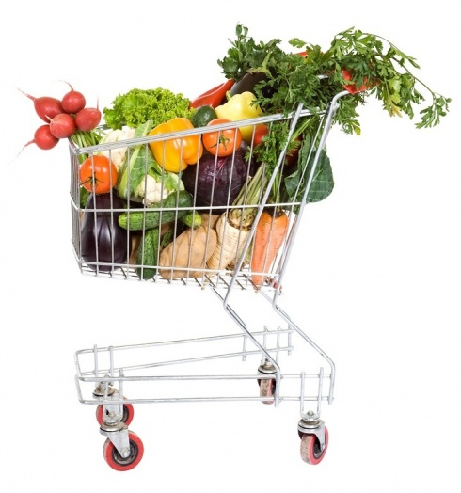

Breakfast Choices

- Cold Cereal: High Fiber (All bran, Cracklin’ Oat Bran, Low-Fat Granola, Grape Nut Flakes, Shredded Wheat, Raisin Bran, Wheaties) with 1/2 Cup Skim Milk 160/0

- Hot Cereal: Oatmeal or cream of wheat or grits made with 1/2 Cup Skim Milk 200/2.5

- Toast Breakfast: Use a low-calorie, high fiber bread like Orowheat light bread, a Sandwich Thin, or English Muffin and 2 Tablespoons honey, jelly or jam 220/2

- Spinach Scramble: 3/4 Cup Eggbeaters or Egg whites with cut fresh spinach. Serve in a 6 to 8 in fat-free flour or corn tortilla 180/2

- French Toast: 2 pieces bread dipped in 6 Tablespoons Eggbeaters or egg whites and ¼ Cup non-fat milk 295/0

- Veggie Omelet: Use cooking spray in a small pan and add 4 Egg Whites or 1 Cup Eggbeaters, diced peppers, mushrooms, onions 140/0. Serve with a toasted English muffin 100/0

- Yogurt with Fruit: 6 oz. non-fat yogurt with fresh fruit: ½ cup Strawberries or blueberries, ½ banana and 2 ounces diced pineapple 150/0

- Chicken Sausage Breakfast: Cook 2 Iserno’s Low-fat Chicken Sausages and dice into 3/4 Cup Eggbeaters or 3 egg whites with cut fresh spinach 220/2.5. Use cooking spray in a small pan and cook for 3 minutes on medium high heat. 220/2.5
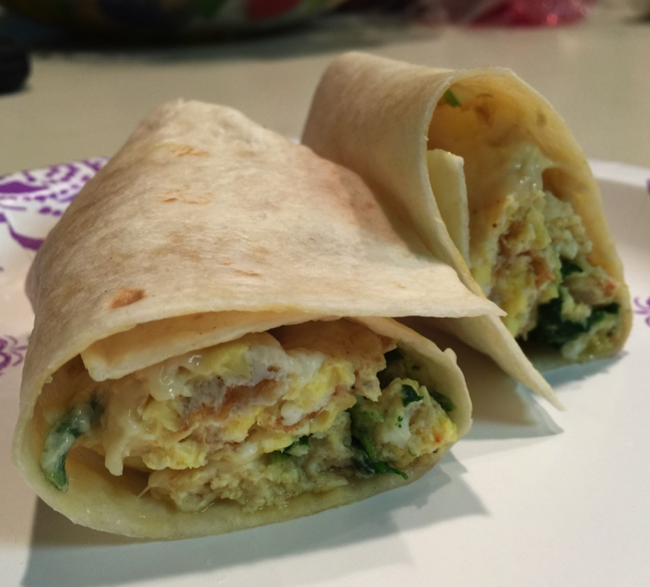

Lunch Choices

- Hummus Sandwich: Whole wheat light bread or a Sandwich Thin, lettuce, tomato, and 3 Tablespoons low-fat hummus 160/6

- Turkey Roll-up: Flour tortilla, non-fat cream cheese, 3 oz. roasted turkey without skin, shredded lettuce and tomatoes 345/5

- Tuna Sandwich: Light bread or a Sandwich Thin, 3 ounces canned albacore tuna packed in water, non-fat mayonnaise, lettuce and tomatoes 260/3.5
- Pita Sandwich: 3 ounces garbanzo beans, veggies, non-fat Italian dressing 380/4.5

- Turkey burger (Trader-Joe’s or 98% Jennie-O Lean) 4 oz. patty, grilled, on whole wheat bun, and barbeque sauce 240/3.5

- Veggie Pasta Salad: 1/2 Cup corkscrew pasta (90/0.5), celery, 3 Tablespoons boiled carrots (10/0), 3 oz. black beans (110/0.5), capers, non-fat Italian dressing 220/1

- Subway Sandwich (6 grams fat or less, no cheese or mayo) 280/3.5

- Chicken Sandwich: skinless breast meat (grilled or roasted) on a Sandwich Thin or other low-fat bread plus barbeque sauce or ketchup or other fat-free condiments 285/6

- Broccoli Potato: Top a 6 oz. baked potato with 4 oz. steamed broccoli & 3 Tablespoons non-fat sour cream) 240/1

- Salad: 8 oz lettuce or spinach (55/1), 2” tomato sliced (20/0), 3 oz Pollock or imitation crab (90/1), 3 Tablespoons mango salsa (30/0) non-fat dressing & small dinner roll (75/2) 270/4

- Yogurt & Fruit: One 4 or 5 ounce container of fat-free Yogurt with bananas, strawberries or other cut-up fresh fruit 160/0

Dinner Choices

- 1 Cup Whole wheat pasta with ½ Cup tomato sauce 175/1

- French Roll pizza – use half; top with ½ Cup tomato sauce, 1 piece string cheese, 1 Cup chopped bell peppers, 1 cup mushrooms, 1 whole tomato sliced 195/3.5

- Home made burrito (1 8” flour tortilla, ½ Cup black beans, ½ Cup brown rice, 2 Tablespoons fat-fee sour cream 410/5.5

- Grilled Tilapia (or other white fish) 4 ounces - marinated in non-fat sauce, with a 2” boiled or baked red potato 235/3

- Turkey burger (Trader-Joe’s or 98% Jennie-O Lean) 4 oz. patty, grilled, on whole wheat bun, and barbeque sauce 240/3.5

- Sweet Potatoes – 1 Cup mashed or 1 9” baked with
2 Tablespoons fat-free sour cream 260/0.5

- Potato wedges (spray cookie sheet lightly with Pam and add cut up one 12 ounce red potato, bake at 400° until slightly crispy, season with salt, and serve with ketchup or barbeque sauce) 270/0

- Chicken Taco: 1 corn tortilla, 1 Tablespoon mango salsa, 3 ounces roasted chicken breast without skin, chopped lettuce, tomato and red onion 270/4

- Rice and Veggies: ¾ Cooked brown rice and sliced veggies simmered in Chicken broth: 1 small onion, 1 bell pepper, 1 Cup mushrooms, 2 stalks celery 330/2

- Broccoli and Potatoes: Take a 6-ounce potato and steam it. When it is almost done, add 6 ounces of broccoli. Clean 2 cloves of garlic, and blend in a food processor with 1 Tablespoon olive oil and ¼ Cup (prepared) chicken broth. Pour Sauce over veggies when served. 235/5

Snack Choices

Remember when your mother told you that if you didn’t stop snacking you would spoil your dinner? Well, at Health Plus we encourage snacking! Snacking frequently keeps you from feeling hungry and overeating. However, for weight loss, it is best to keep portion sizes small. Pre-portioned packages of foods like yogurt and crackers may be helpful so if you purchase a box of crackers, portion out handfuls into sandwich bags.
- Snack-Type Food: Matzo with jam, SpecialK Rice crackers with Fat-free sour cream dip, Rice cakes, Pretzels, air-popped or lower fat microwave popcorn - average ~130/1.5

- Yogurt with Fruit: non-fat light fruit or non-fat plain with fresh fruit 140/0

- Fruit Sundae: ½ Cup Apple Sauce with 1 Cup of mixed fresh diced fruit (strawberries, apple, pineapple, blueberries, grapes) and ½ a sliced banana; top with 1 teaspoon Jam 200/0

- Corn tortilla and salsa heated in microwave 100/2

- English muffin pizza (top with spaghetti or pizza sauce, diced veggies such as mushrooms, onions, peppers) 150/0

- Fresh fruit (apples, oranges, clementines, banana, grapes, peach, pear, pineapple slices, seasonal berries, etc) 60-130/0

- Fruit Cup: Packed in water or own juices (applesauce, peaches, pears, mandarin oranges, pineapple etc) 70/0

- Fresh vegetables (sweet peppers, baby carrots, celery sticks, sliced jicama, etc) 40 - 90/0

- Skinny Cow Low-fat frozen dessert average ~140/3

- Rice Chex - 1 cup dry makes a great snack with crunch 110/0

- Go Snack: one That’s It Fruit Bar 100/0, or one Low-Fat Granola bar 140/2.5 or a Snack Box of Raisins 100/0

Beverage Choices

Yes it’s true; water is still the best choice for meeting your fluid needs. However, beverages containing sugar substitutes like Splenda, NutraSweet, & Equal can be safely included in your daily meal plan unless you find that they make you hungry. If you do include beverages with artificial sweeteners, try to limit them to 3 servings a day. If you are having trouble sleeping, and especially if you are taking weight loss medications, try cutting down on the amount of caffeine you drink. To avoid caffeine choose caffeine-free or decaffeinated coffee, teas, and sodas.

- Water (tap, bottled)

- Diet V-8 Splash 50/0 for 8 oz. glass

- Iced Tea - sweeten by the glass with Truvia or Stevia, organic cane sugar or honey

- Vegetable Juice eg. Carrot Juice 40/0 for 8 oz. glass

- Tea with honey, Truvia or organic cane sugar

- Coffee with non-fat milk – for sweeteners, use organic cane sugar instead of refined white sugar, and the least amount possible

- Light cranberry juice 50/0 for 8 oz. glass

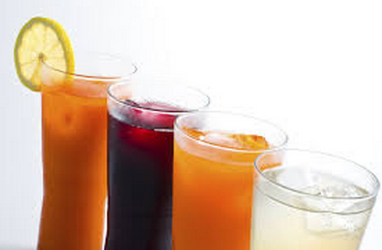

Weekly Menu #2
 | Day 1 |  | Day 2 |  | Day 3 |  | Day 4 |  | Day 5 |  | Day 6 |  | Day 7
Breakfast | Cereal with skim milk 160/0  *see meal lists |  | Cereal with skim milk 160/0 *see meal lists |  | Chicken Sausage Breakfast 220/2.5  *see meal lists |  | Yogurt with Fresh Fruit 150/0  *see meal lists |  | 8 oz non-fat yogurt 100/0  ¼ cup LF granola 95/1.5 |  | French Toast 295/0 + 4 Tbs Sugar-free syrup 60/0 *see meal lists |  | Veggie Omelet w/English Muffin  240/0  *see meal lists
Snack | 1 Apple 100/0.5 |  | 1 Pear 100/1 |  | Yogurt with Fresh Fruit  150/0 |  | Pineapple (fresh)  1 cup 75/1 |  | Cantaloupe  1 cup 55/0 |  | 1 Apple 100/0.5 |  | Grapes  1 cup 100/0
Snack | Baby Carrots  1 cup 90/0 |  | Rice Chex  1 cup dry 110/0 |  | Celery - 5 stalks 65/0 |  | Bell Pepper  1 sliced 45/0 |  | That’s It Fruit Bar 100/0 |  | Cumber–1 sliced & vinegar 40/0 |  | Corn Tortilla & salsa 100/2  *see snack list
Lunch | Broccoli Potato 240/1  Salad 195/2  *see meal lists |  | Turkey Burger 240/3.5  Salad 195/2  *see meal lists |  | Turkey Roll-up 245/3.5  *see meal lists |  | Tuna Sandwich 260/3.5  *see meal lists |  | Pita Sandwich 245/2  *see meal lists |  | Hummus Sandwich 160/6  *see meal lists |  | Gardenburger 250/3  *see meal lists
Snack | Bell Pepper  1 sliced 30/0 |  | Rice Cakes (2) 70/0.5 |  | Fruit Cup 70/0 |  | That’s It Fruit Bar 100/0 |  | Cumber sliced & vinegar 40/0 |  | 1 Pear 100/1 |  | 1 Orange 60/0
Snack | Popcorn -1 bag low-fat 240/3 |  | Pretzel Crisps  (1 serving) 110/2 |  | 1 Pear 100/1.5 |  | Tomato sliced & vinegar 30/0 |  | Cantaloupe  1 cup 55/0 |  | Rice Chex  1 cup dry 110/0 |  | Pretzel Crisps  (1 serving) 110/2
Snack | 1 Orange 60/0 |  | 1 Banana 100/0 |  | 2 Plums 80/1 |  | Fruit Cup 70/0 |  | That’s It Fruit Bar 100/0 |  | Grapes  1 cup 100/0 |  | Bell Pepper  1 sliced 30/0
Dinner | Whole Wheat Pasta 175/1  Salad w/roll 270/4  *see meal lists |  | Rice and Veggies 330/2  Salad 195/2  *see meal lists |  | 2 French Roll Pizzas 390/7  Salad 195/2  *see meal lists |  | Home-made Burrito 410/5.5  Salad 195/2  *see meal lists |  | Chicken Tacos 270/4  Salad 195/2  *see meal lists |  | Grilled Fish and Potato wedges  370/3  *see meal lists |  | Sweet Potatoes & 4 oz baked or broiled Chicken Breast 390/1.5
Snack | 1 oz. pretzels 110/1 |  | 1 Pear 100/1.5 |  | 2 Kiwis 95/1 |  | Cantaloupe  1 cup 55/0 |  | Grapes  1 cup 100/0 |  | Fruit Sundae 200/0 *see meal lists |  | Yogurt w/fruit 150/0
Total: | 1670/12.5 |  | 1710/14.5 |  | 1610/18.5 |  | 1390/12 |  | 1355/9.5 |  | 1475/10.5 |  | 1445/8.5

Grocery List – Weekly Menu #2

Canned/Packaged Food
Raisin Bran
Oatmeal
Rice Chex
Granola, low-fat (Trader Joes)
Tuna, canned, packed in water
Garbanzo beans, canned
Black Beans, canned
Barbeque sauce
Spaghetti sauce

Bread/Grain/Rice/Pasta
Whole wheat light bread (Orowheat etc)
Whole wheat buns
Whole wheat rolls
Whole wheat pasta
Tortilla, corn & Canteca non-fat Flour (Winco)
Rice, brown & wild

Fruit
1 pkg Fruit cups
2 Bananas
2 Apples
6 Oranges / tangerines
1 Pears
Diet V-8 Splash
2 small Cantaloupes
Seedless Red or Green Grapes
2 pkgs Pineapple or fresh cut pineapple (Winco)
1pkg Strawberries
1 pkg Blueberries
4 Plums

Vegetables
Lettuce
Spinach
5 Tomatoes
1 Cucumbers
2 Bell peppers
1 bunch Celery
Mushrooms
4 Red Potatoes, 2 Baking Potatoes
Broccoli
3 packages Baby carrots
Onions
2 Yams or Sweet Potatoes

Dairy/ Eggs
Non-fat milk or soy milk
Egg Substitute (Egg Beaters)
1 doz Jumbo eggs
Jumbo Eggs
Sour cream, non-fat
2 Non-fat Yogurt, with fruit 6 oz servings
1 pkg Freshly Shaved Parmesan Cheese
1 pkg Fat-Free Feta Cheese

Snacks/ Desserts
1 pkg Pretzel Thins or Whole wheat pretzels
6 That’s It Fruit bars
1 Granola bars, low-fat
1 pkg Rice cakes

Condiments/ Spreads/ Spices
Balsamic Vinegar, Rice Vinegar
Jam (no High Fructose Corn Syrup)
Fresh Salsa and/or Fresh Mango Salsa
Mayonnaise, non-fat
Italian salad dressing, non-fat
Mustard
Ketchup
Pam Spray

Meat/Fish/Poultry
Chicken breasts, boneless, skinless
Iserno’s Low-Fat Chicken Sausages
Meatless Burger (Gardenburger, Boca Burger)
Talapia or other white fish fillet
2 Packages of Pollack or Imitation Lobster or Crab
¾ lb Roasted Turkey Breast for Sandwiches

